The world of graphic design isn't all about serious messages and brand identity – there's plenty of room for laughter too! One hilarious pitfall is the unfortunate placement of text. Imagine a billboard for a new hair salon with the stylist's name accidentally positioned right where it seems like they're giving a model a bad haircut. These unintentional double entendres can leave viewers in stitches, forever associating that brand with a good chuckle.

Another source of amusement comes from stock photo mishaps. Imagine a fitness center brochure featuring a determined athlete lifting weights... with terrible posture that would make any physiotherapist cringe. These nonsensical stock photo choices can turn even the most serious design into an unintentional comedy act.

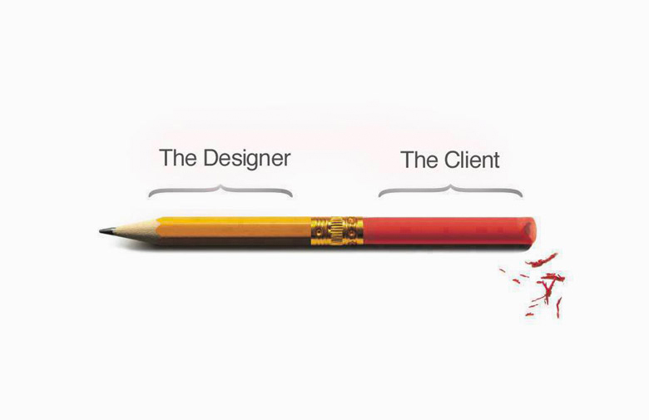

Finally, there's the beauty (or horror?) of design fails that go unnoticed until it's too late. Imagine a children's clothing line with a cute illustration of a bunny – except, upon closer inspection, the bunny's ears suspiciously resemble something much less adorable. These hilarious design gaffes become instant internet legends, a cautionary tale reminding us to double-check everything before hitting print!